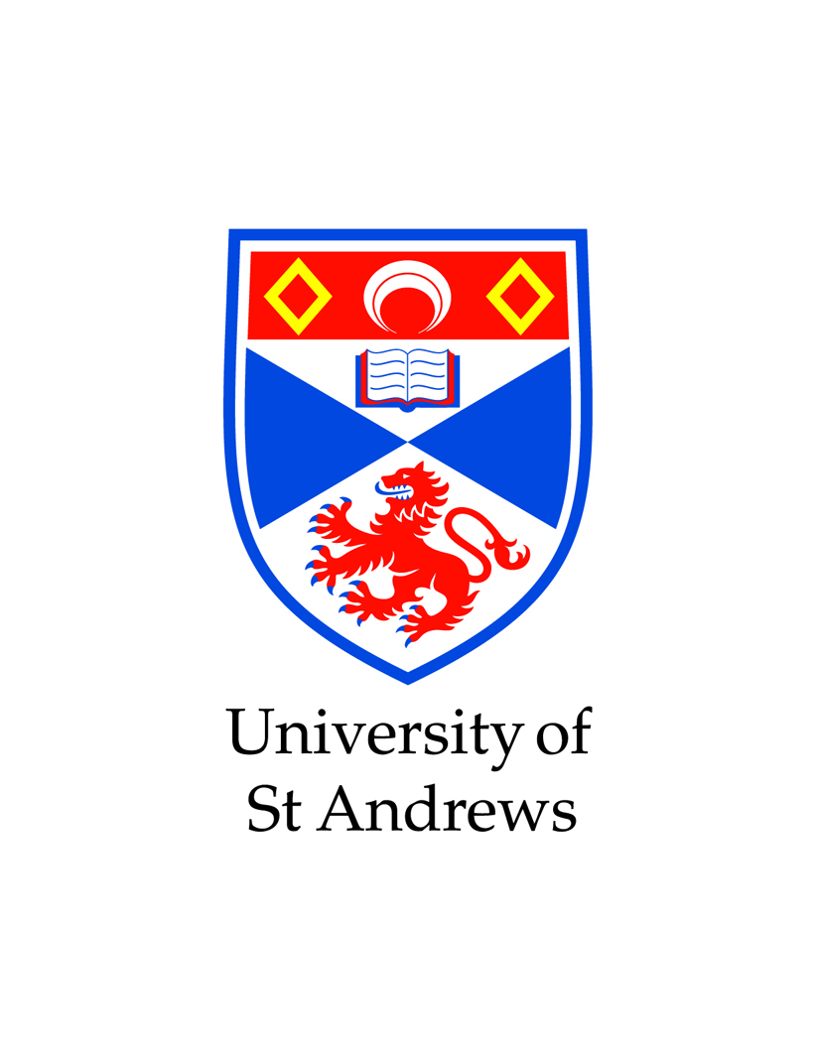 | Participant Information Sheet

Project Title
Molecular Structure Drawing Prediction

What is the study about?

We invite you to participate in a research project to measure the effectiveness of my prediction tool for drawing chemical molecular structures. The aim of the project to speed up locating these structures in a database when required to draw a strucutre.

This study is being conducted as part of my, Jacob Alexander Cameron Rivett Honors Degree Dissertation in the School/Department of Computer Science.

Do I have to take Part?

This information sheet has been written to help you decide if you would like to take part. It is up to you and you alone whether or not to take part. If you do decide to take part you will be free to withdraw at any time without providing a reason.

What would I be required to do?

You will be asked to draw using a web-based chemical structure editor molecular structures given to you either in the form of a Lewis Structure OR a Condensed formula. You will do it without the prediction tool and then do it with the predictions accessible.

Will my participation be Anonymous and Confidential?

Only the researcher(s) and supervisor(s) will have access to the data which will be kept strictly confidential. Your permission maybe sought in the Participant Consent form for the data you provide, which will be anonymised, to be used for future scholarly purposes. All data will be delete once the project is terminated.

Storage and Destruction of Data Collected

The data we collect will be accessible by the researcher(s) and supervisor(s) involved in this study only. Your data will be stored for a period of at least 1 year before being destroyed. The data will be stored securely in the school of computer science database and behind my password protected computer and no where else.

What will happen to the results of the research study?

The results will be finalised by 2012 and written up as part of my Honours Degree Thesis.

Reward

<Details of reward e.g. prize draw, if applicable>

Questions

You will have the opportunity to ask any questions in relation to this project before giving completing a Consent Form.

Consent and Approval

This research proposal has been scrutinised and been granted Ethical Approval through the University ethical approval process.

What should I do if I have concerns about this study?

A full outline of the procedures governed by the University Teaching and Research Ethical Committee is available at http://www.st-andrews.ac.uk/utrec/guidelinespolicies/complaints/

Contact Details

Researcher: Jacob Alexander Cameron Rivett

Supervisor: Simon.Dobson
Contact Details: simon.dobson@st-andrews.ac.uk

